-----------------------------sim 1-----------------------------------------

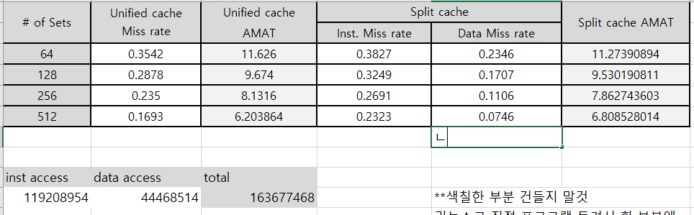cc1

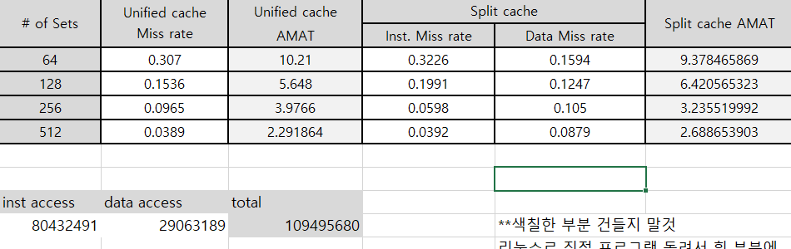compress

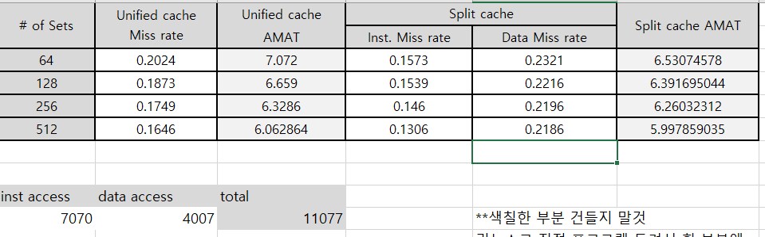anagram

-----------------------sim 2---------------------

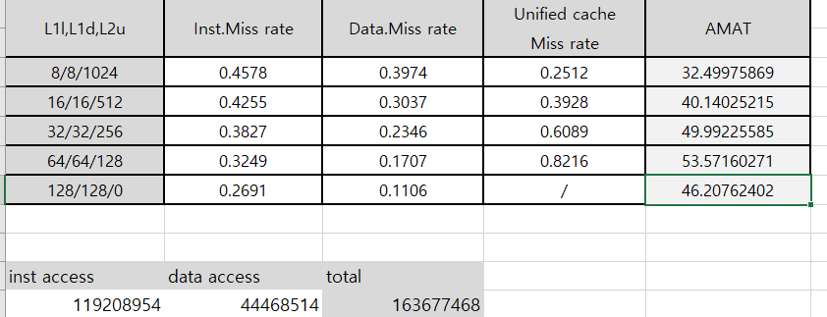cc1

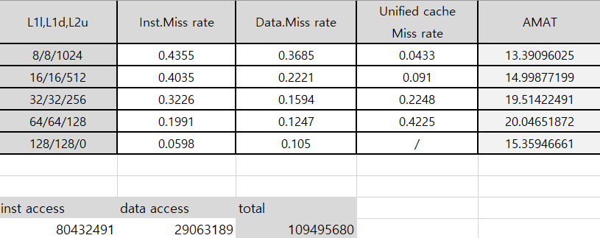compress

8/8/1024 AMAT 13.44162445로 수정

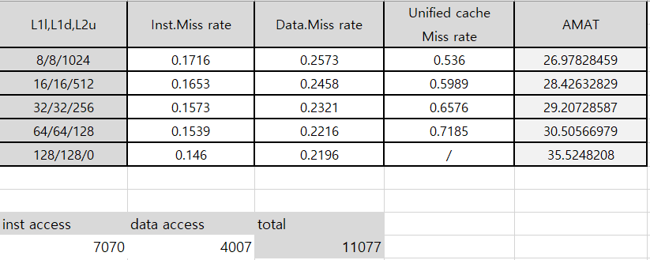anagram

8/8/1024 AMAT 26.99876689로 수정

----------------------sim3---------------------

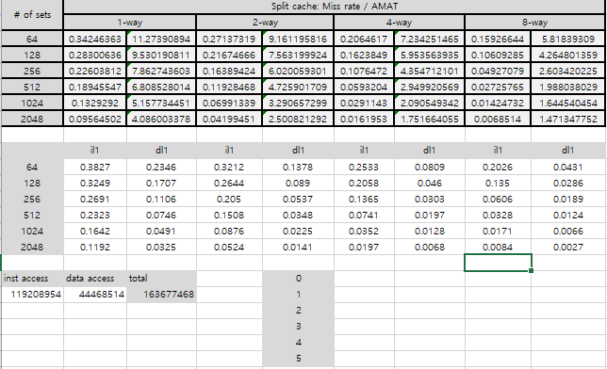cc1

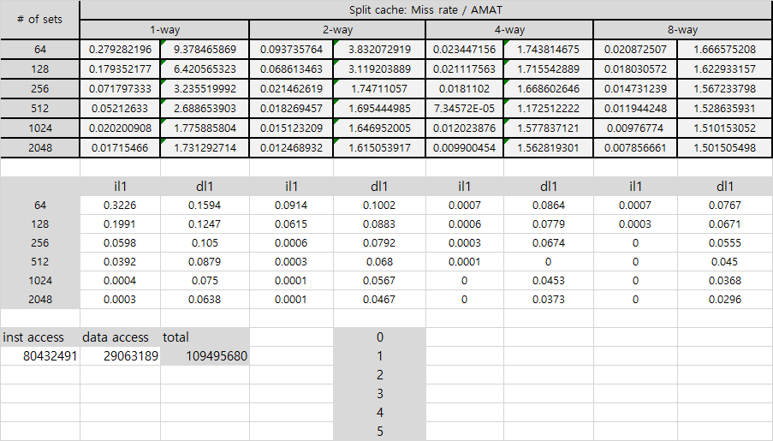

Compress

0.0558

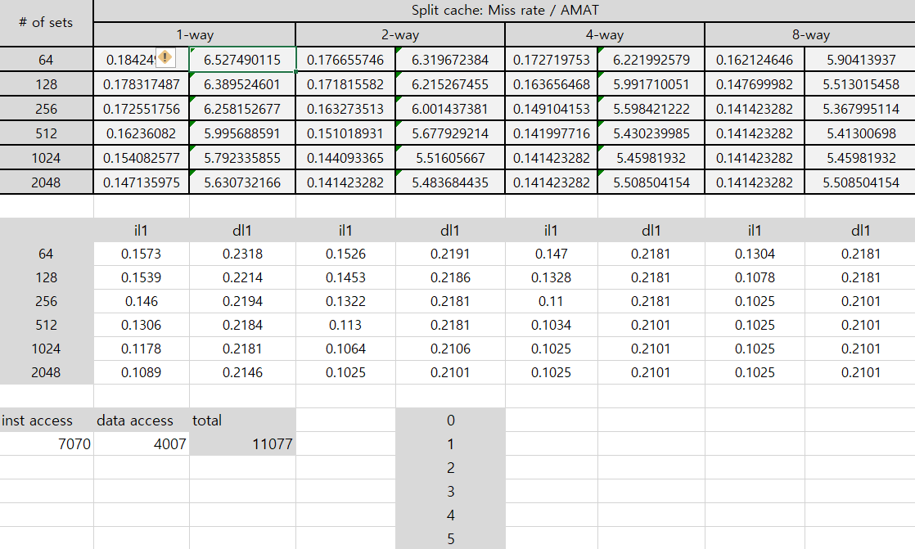anagram

-----------------------sim 4----------------------

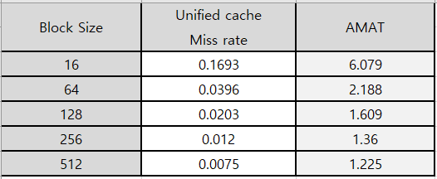cc1

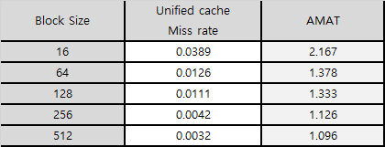compress

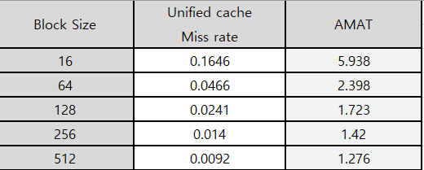anagram

----------------------sim 5---------------------

Sim 1 방식

|  |  |  |  |
| --- | --- | --- | --- |
| Sets | Unified miss | Inst miss | Data miss |
| 64 | 0.0276 | 0.0057 | 0.0424 |
| 128 | 0.0178 | 0.0044 | 0.0329 |
| 256 | 0.0117 | 0.0034 | 0.0283 |

sim 2 방식

|  |  |  |  |  |
| --- | --- | --- | --- | --- |
| L1I/L1D/L2U | Inst miss | Data miss | Unified miss | AMAT |
| 8/8/1024 | 0.4653 | 0.0983 | 0.0164 |  |
| 16/16/512 | 0.2739 | 0.0611 | 0.0309 |  |
| 32/32/256 | 0.0057 | 0.0424 | 0.4137 |  |

Il1 access : 3537035774

Dl1 access : 1058949968

Sim 3 방식

|  |  |  |  |  |  |  |
| --- | --- | --- | --- | --- | --- | --- |
| Sets | Split | | | | | |
| 1 | | 2 | | 4 | |
| 64 | 0.0057 | 0.0424 | 0.0042 | 0.0237 | 0.0029 | 0.0236 |
| 128 | 0.0044 | 0.0329 | 0.0028 | 0.0236 | 0.0016 | 0.0236 |
| 256 | 0.0034 | 0.0283 | 0.0015 | 0.0236 | 0.0003 | 0.0236 |

Inst / data

Sim 4 방식

|  |  |  |
| --- | --- | --- |
| Block size | Uni miss | AMAT |
| 16 | 0.0087 |  |
| 64 | 0.0013 |  |
| 128 | 0.0008 |  |

Sim 4 방식 추가, sim3 마지막 2개 추가

****************** 수정사항 ********************

Sim 3에 Associativity 관련 수식 오류. 해당 값 수정 필요